First Line of your Thesis/Dissertation Title

Second Line of Title if Necessary

Three Line Limit

Isaac Newton

A dissertation/thesis submitted to the faculty of
Brigham Young University
in partial fulfillment of the requirements for the degree of

Doctor of Philosophy/ Master of Science

Nikola Tesla, Chair
Alexander G. Bell
Isambard K. Brunel

Department of (department name)

Brigham Young University

Copyright © 2015 Isaac Newton

All Rights Reserved

First Line of Title
Second Line if Necessary
Exactly as on Title Page

Isaac Newton
Department of (Whatever) Engineering
Doctor of Philosophy/Master of Science



Abstract
The abstract is a summary of the work with emphasis on the findings of the study. It must be single spaced and no more than one page in length. It must match the same font and size as the rest of the work. The abstract precedes the acknowledgment page and the body of the work.
Lorem ipsum dolor sit amet, consectetuer adipiscing elit. Maecenas porttitor congue massa. Fusce posuere, magna sed pulvinar ultricies, purus lectus malesuada libero, sit amet commodo magna eros quis urna. Nunc viverra imperdiet enim. Fusce est. Vivamus a tellus. Pellentesque habitant morbi tristique senectus et netus et malesuada fames ac turpis egestas. Proin pharetra nonummy pede. Mauris et orci.
Aenean nec lorem. In porttitor. Donec laoreet nonummy augue. Suspendisse dui purus, scelerisque at, vulputate vitae, pretium mattis, nunc. Mauris eget neque at sem venenatis eleifend. Ut nonummy. Fusce aliquet pede non pede. Suspendisse dapibus lorem pellentesque magna. Integer nulla.
Donec blandit feugiat ligula. Donec hendrerit, felis et imperdiet euismod, purus ipsum pretium metus, in lacinia nulla nisl eget sapien. Donec ut est in lectus consequat consequat. Etiam eget dui. Aliquam erat volutpat. Sed at lorem in nunc porta tristique. Proin nec augue. Quisque aliquam tempor magna. Pellentesque habitant morbi tristique senectus et netus et malesuada fames ac turpis egestas.
Nunc ac magna. Maecenas odio dolor, vulputate vel, auctor ac, accumsan id, felis. Pellentesque cursus sagittis felis. Pellentesque porttitor, velit lacinia egestas auctor, diam eros tempus arcu, nec vulputate augue magna vel risus. Cras non magna vel ante adipiscing rhoncus. Vivamus a mi. Morbi neque. Aliquam erat volutpat. Integer ultrices lobortis eros.

Keywords: gravitation, conservation, GPS, Kalman filtering

Acknowledgments
Students should acknowledge funding sources. They may also use the acknowledgment page to express appreciation for the committee members, friends or family who provided support or aided the research, writing or technical aspects of the thesis/dissertation. Acknowledgments should be simple and in good taste.
Lorem ipsum dolor sit amet, consectetuer adipiscing elit. Maecenas porttitor congue massa. Fusce posuere, magna sed pulvinar ultricies, purus lectus malesuada libero, sit amet commodo magna eros quis urna. Nunc viverra imperdiet enim. Fusce est. Vivamus a tellus. Pellentesque habitant morbi tristique senectus et netus et malesuada fames ac turpis egestas. Proin pharetra nonummy pede. Mauris et orci. Aenean nec lorem. In porttitor.
Donec laoreet nonummy augue. Suspendisse dui purus, scelerisque at, vulputate vitae, pretium mattis, nunc. Mauris eget neque at sem venenatis eleifend. Ut nonummy. Fusce aliquet pede non pede. Suspendisse dapibus lorem pellentesque magna. Integer nulla. Donec blandit feugiat ligula. Donec hendrerit, felis et imperdiet euismod, purus ipsum pretium metus, in lacinia nulla nisl eget sapien. Donec ut est in lectus consequat consequat. Etiam eget dui.

Table of Contents
List of Figures vi
List of Tables vii
Nomenclature viii
1 Introduction 1
1.1 Document Formatting 1
2 Captions, Figures, Tables, Equations, and Cross References 3
2.1 Captions and Figures 3
2.2 Tables 4
2.3 Equations 4
2.4 Cross References 5
2.5 Capitalization of Reference Labels 5
2.6 Rotating Figures and Tables 5
2.7 Use of Units 6
3 Section, Page Numbering, Table of Contents, and Lists 8
3.1 Sections 8
3.2 Page Numbering 8
3.3 Table of Contents 9
3.4 Lists of Figures and Tables 9
3.5 Bibliography 9
4 Article-based Chapters 11
4.1 Some Additional Comments 11
5 Conclusions 12
References 13
Appendix A College of Engineering Formatting Requirements 14
Appendix B Electronic Document Submission 16
B.1 Bookmarks 16
Appendix C Template Format Guidelines 18
C.1 Document Margins 18
C.2 Page Numbering 18
C.3 Line Spacing 19

List of Figures
Figure 2.1: Method for inserting a caption. 3
Figure 2.2: Landscape tables and figures. 7
Figure B.1: PDF thesis document showing ETD bookmarks. 16

List of Tables
Table 2.1: Curve numbers for associated basins including minimum and maximum amounts of curvature. 4

Nomenclature
$α$ Angle of attack
$β$ Sideslip angle
$γ$ Climb angle
$x$ State vector
Re Reynolds number
$c$ Speed of light in a vacuum
$h$ Planck constant
$P$ Covariance matrix
$p$ Roll rate
$q$ Pitch rate
$r$ Yaw rate

Introduction
The opening chapter of a thesis or dissertation will typically introduce the body of research. At the beginning of a chapter, it is common to provide some introductory text. Instead of discussing research, this template document will highlight how use Microsoft Word to prepare a thesis or dissertation document for submission in the College of Engineering at BYU. A concise statement of the College of Engineering formatting requirements can be found in Appendix A.

Document Formatting
The formatting guidelines that you will use to prepare your thesis are outlined briefly in the next several chapters. The narrow, single-column format of this document is based on long-standing principles of typography [1]. This format is easy to read compared to the wide-column, double-spaced format used previously. The styles used in this template are outlined in the next several sections. To give a better sense of the format of the document, we will occasionally throw in some random Latin text to take up white space. We set it apart from the text requiring your attention with a grey font color.
Pellentesque habitant morbi tristique senectus et netus et malesuada fames ac turpis egestas. Proin pharetra nonummy pede. Mauris et orci. Aenean nec lorem. In porttitor. Donec laoreet nonummy augue.

Normal Style
Many of the formatting aspects of the text, such as the font, font size, line spacing, indentation, and justification, are defined by the Normal style. Furthermore, many of the other styles used in the document are based on the Normal style definition. The most efficient way to make formatting changes to the text of the entire document is to modify the Normal style. This can be done by right-clicking on the Normal style in the Styles block under the Home tab and selecting Modify. Any modifications you make to the Normal style will be made to the entire document. For large documents, like a thesis or dissertation, the Styles feature of MS Word helps ensure that formatting changes are applied uniformly across the document.

Heading Styles
All the titles in this document use a Heading style. Heading 1 should be used for chapter titles and Heading 2 and Heading 3 for subtitles.
Lorem ipsum dolor sit amet, consectetuer adipiscing elit. Maecenas porttitor congue massa. Fusce posuere, magna sed pulvinar ultricies, purus lectus malesuada libero, sit amet commodo magna eros quis urna. Nunc viverra imperdiet enim.
Lorem ipsum dolor sit amet, consectetuer adipiscing elit. Maecenas porttitor congue massa. Fusce posuere, magna sed pulvinar ultricies, purus lectus malesuada libero, sit amet commodo magna eros quis urna.
Nunc viverra imperdiet enim. Fusce est. Vivamus a tellus.

Caption Styles
The Caption style is used for defining captions beneath figures, above tables and next to equations. Section 2.1 addresses inserting captions so that numbering will remain consistent.

Captions, Figures, Tables, Equations, and Cross References

Captions and Figures
To insert figure and table captions and equation numbers use the References-Tab>Insert Caption command as shown in Figure 2.1. Center figures on the page and use extra spacing above and below figures to separate them from the text. Be consistent throughout the document. See Appendix B.5 for figure spacing specifications.

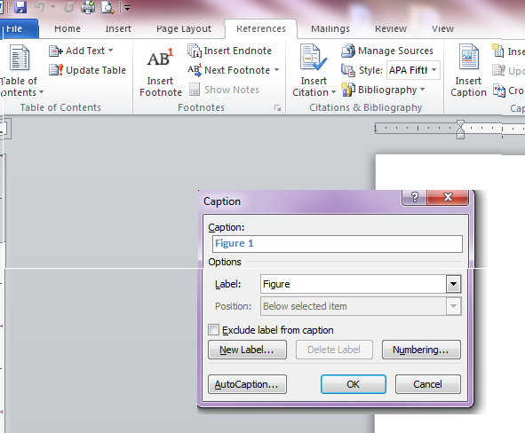
Figure 2.1: Method for inserting a caption.
Captions are centered below the figure, running the width thereof. If more than one line is needed, single space and left and right justify the caption. When typing the caption, capitalize the first word with the remaining words in lower case. Follow the same formatting with all future captions. Select Figure, Table or Equation and the proper Numbering Format. Thereafter, numbering will be automatically configured when additional figures and their captions are inserted.

Tables
Center tables on the page and use extra spacing above and below tables to separate them from the text. See Appendix B.5 for table spacing specifications. Be consistent through the document. Table captions are centered above the table and if longer than one line, use single spacing, left and right justified, as shown in Table 2.1. Table captions are created in the same way as figure captions so that they are automatically updated. Long tables may be continued onto the next page, however, only the table number needs to be listed (e.g., Table 2.1 continued). In this case, column headings should be relisted. Notice that in the table, we have eliminated the vertical rules separating the columns. Doing so creates tables that are less cluttered and easier to read.
Table 2.1: Curve numbers for associated basins including minimum and maximum amounts of curvature.
Basin  Name | Curve  Number | Minimum | Maximum
1B | 68.5 | 49.2 | 84.1
2B | 66.2  65.4 | 46.4 | 82.7
3B | 66.2  65.4 | 45.5 | 82.3
4B | 65.1 | 45.1 | 82.1
5B | 66.6 | 46.9 | 83.0
6B | 65.8 | 46.2 | 82.5
7B | 69.4 | 50.3 | 84.6

Equations
The Insert>Equation command can be used for the insertion of equations. Insert a caption (number) for your equations as explained in Section 2.1. Again, inserting the numbers as captions will ensure consistency in numbering as other equations are added or deleted. Equations should be placed on a separate line with the equation centered. The caption (number) can be moved to the right margin by using a right-justified tab at the right margin, as shown below. Remember that equations should be treated as part of the text. Use punctuation as necessary. As an example, the surface area of a cylinder is given by
$S=2πr\left(r+h\right)$, (2.1)
where $r$ is the radius of the cylinder and $h$ is the height of the cylinder. Just in case you have forgotten, the area of a circle can be written as
$A= \frac{π}{4}d^{2}$, (2.2)
where $d$ is the diameter of the circle. These equations have been formatted using the Equation number style with parentheses manually added around the equation number. The tab added before the equation centers the equation and the tab added after the equation right justifies the equation number. The Insert>Equation option has been used to type variable names in the text to ensure that their font matches the font of the variables in the equation. Attention to detail creates a beautiful document. Be aware that a single-line equation may cause a widow or orphan (one line of text, a subtitle, or an equation by itself, either at the bottom or top of a page).

Cross References
Cross references are automatically created when you insert captions. Cross references make it possible to automatically generate lists of figures, lists of tables, and bookmarks, as explained in Sections 3.4 and A.1. When finished with your document check to make sure all captions are properly reflected in these lists. To view the cross references in your document, use the References> Cross-reference command.

Capitalization of Reference Labels
Throughout your document, you will refer to figures, tables, equations, chapters, appendices, and sections by name (e.g., Figure 2.1, Section 3.4, Equation 2.1, and so on). You may choose to capitalize these reference labels, or to leave them uncapitalized (e.g., figure 2.1, section 3.4, equation 2.1). The choice is yours, just be consistent – all reference labels should be capitalized, or uncapitalized.

Rotating Figures and Tables
Large figures and tables can be rotated to be in landscape format as shown in Figure 2.2. The figure/table must have the top of the figure/table on the left side of the page (when viewed in portrait view). Captions can be inserted into a text box and placed beneath the figure or above the table. The page number is placed at the bottom center of the page (landscape view). This works well for electronic viewing. You may move the page number to the bottom of the page (portrait view) for the printing of your thesis, although, this is not required.

Use of Units
Units should be appropriately used for all measurements and data presented in the document. Standard abbreviations for units (e.g., m for meters, N for newtons, in. for inches) should be used whenever data is presented. For example, the shaft was 1.23 cm in diameter. Notice that there is a space between the number and the unit, and the unit is typeset in vertical (roman) text and is not italicized. Italics is reserved for emphasis and for mathematical variables. Periods are not used after abbreviations except in the special case of the abbreviation for inches as in. to avoid confusion with the word in. Units are typically spelled out when they are used without data. For example, newtons are a measure of force, while kilograms are a measure of mass.

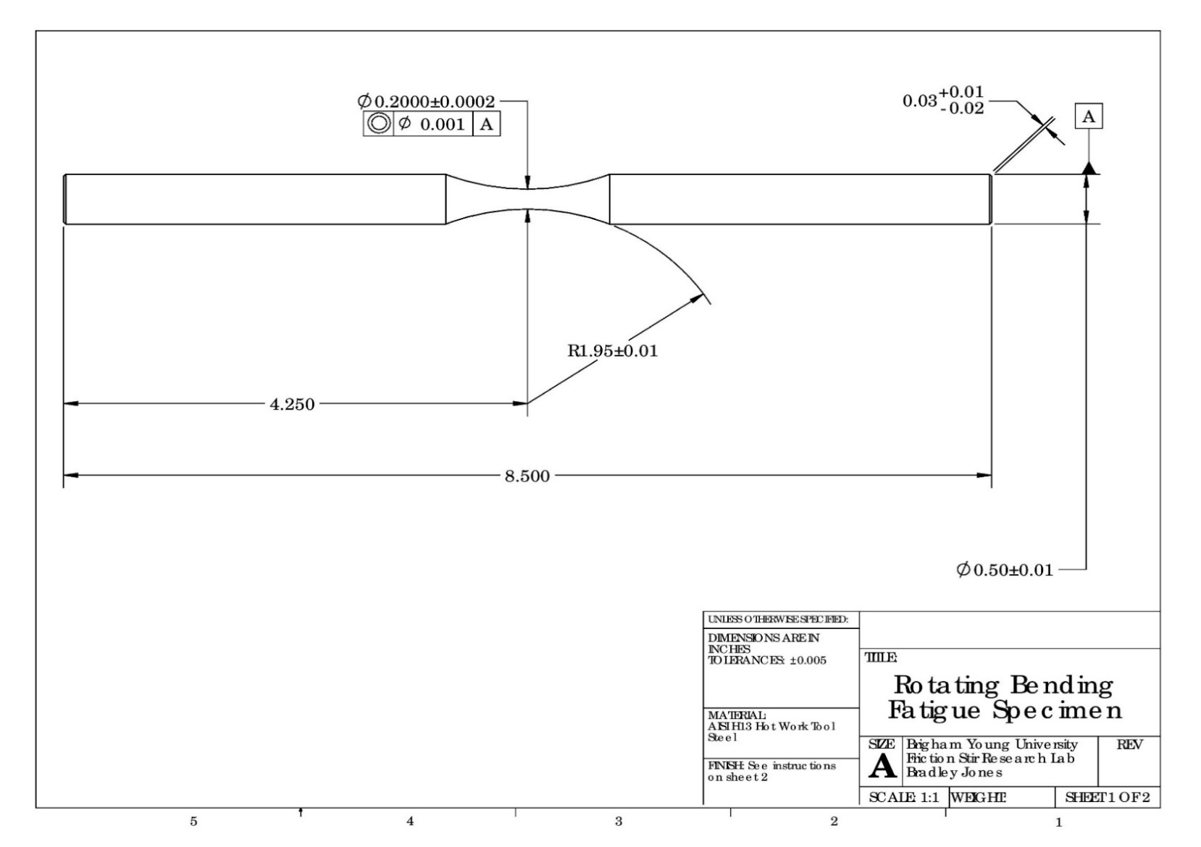
Figure 2.2: Landscape tables and figures.

Section, Page Numbering, Table of Contents, and Lists
This chapter will tell what you need to know about formatting your thesis using sections. It will also describe the page numbering format to be used and how to create your table of contents and other lists.

Sections
Your document is divided into sections to allow the layout or formatting of various parts of the document to be different from each other. Sections are created using the Insert>Break>Section Break command.
Section breaks have been created prior to the Table of Contents, where page numbering begins, and at the end of each chapter to ensure each new chapter starts on an odd page number (which are also front pages of the document.) To see the location of section breaks, use the Home>Show/Hide Button.

Page Numbering
The page numbers have been inserted in the footers. You can modify them by using the Insert>Page Numbers command.
The portion of your document before the first page of Chapter 1 is called the front matter and is numbered with lowercase Roman numerals. The title page of your document is the first page of the front matter and must be formatted according to BYU Graduate Studies specifications. An optional custom title page can be inserted after the BYU-required title page. This page allows the student to design an attractive title page that utilizes text and graphics to convey the area of research. The Abstract and Acknowledgment sections follow the title page. None of the pages prior to the Table of Contents have page numbers written on the page.
The Table of Contents has been set to start at page v in your document. Pay attention to this to ensure that your page numbering is correct. Page numbers have been formatted to continue from one section (chapter) to the next in the main body, starting with page 1 at the beginning of Chapter 1.

Table of Contents
There is no need to list entries in the Table of Contents for pages prior to the Table of Contents. The entries for subsequent pages are created automatically by updating the Table of Contents when you are all finished. To do this, first select the Table of Contents page, then click Update Table at the top-left hand corner of the page.

Lists of Figures and Tables
Your List of Figures and List of Tables sections can be generated the same way as the Table of Contents. However, to generate these lists automatically you must have used captions and cross references as explained previously.

Bibliography
Microsoft Word allows you to create a list of citations that can be used to form your bibliography. In engineering, it is common to give your bibliography list the title References and we will follow that convention. Here’s an example of a journal paper citation [1]. You may choose to have your bibliography appear as a numbered list in order of appearance or an alphabetical list by the lead author’s last name. For the bibliography format, we suggest IEEE, which produces a numbered list. Here are examples of a book citation [2] and a conference paper citation [3]. There are other types of citations that you may use, such as book chapters and websites. A dissertation or thesis can be cited using the Book citation type with the Publisher field having both the document type and university name (e.g., Ph.D. dissertation, Brigham Young University or Master’s thesis, Purdue University) [4] [5]. Do not include a city name in the City field for a dissertation or thesis citation.
Building a bibliography in MS Word is straightforward. Let’s assume that you’ve written a sentence containing information that you learned from conference paper and that you need to create a citation. With the cursor positioned after the information to be cited, select References>Insert Citation. The Create Source dialog window will open. Select Type of Source to be Conference proceeding. Add the author information to the Author field. Enter the author names in lastname, firstname format. Separate multiple authors with a semicolon. Add the title of the paper, the conference publication name, and the year to the appropriate fields and click OK. Once you have done this, a numbered citation will be added to your paper and the reference source will be added your Citations list. To see the list of citations associated with your paper select References>Citations. Repeat this process for each citation that you would like to add to your document.
To add your bibliography, place the cursor at the location in your document where you want the bibliography to be placed. Select References>Bibliography>Bibliography to create your bibliography. Some minor formatting of the reference list may be needed. Using the tools icon under the Citations tab, you can edit a specific citation’s source information after it has been created. A Google search can lead you to additional details on creating a bibliography in MS Word.

Article-based Chapters
With the allowed changes in thesis and dissertation formatting, BYU Graduate Studies now allows students to insert journal or conference articles as chapters into their thesis/dissertation document. To do so, the student must be a primary author. The formatting of an article-based chapter must be fully consistent with the formatting defined in this document with chapter, section, equation, figure, and table numbering integrated accordingly. Article-based chapters must include a complete citation and the following statement: “I hereby confirm that the use of this article is compliant with all publishing agreements.” The paragraph below is an example of how this could be done. It should appear immediately following the chapter title.

This chapter is composed from a paper entitled “Really great research from a BYU engineering student” published in the journal Awesome Engineering [6]. I hereby confirm that the use of this article is compliant with all publishing agreements.

Some Additional Comments
The publication of a conference or journal article is a significant milestone for a graduate student and should be an objective for all students pursuing graduate research in the College of Engineering. We encourage the use of article-based chapters in theses and dissertations if it aligns with the goals and objectives of the research. Articles, however, are often constrained in length forcing the exposition to be more concise or narrow in scope than may be desired for the intended audience of the thesis/dissertation. For example, if an objective is to guide the learning of subsequent graduate-student researchers, it may be beneficial to include additional details or a broader discussion that may be more tutorial in nature. Often more results from a wider variety of cases would be included in a dissertation or thesis than would be possible in a journal or conference publication. Your graduate committee will help guide your efforts in these matters.

Conclusions
The purpose of this template is to provide basic instructions in creating your dissertation/thesis document. If you need further tutoring, please visit the Writing Center in the JKB. If you discover something that will make this template more useful, please feel free to make recommendations.
Regardless of whether this template or some other method of formatting is employed, the student is responsible for following the guidelines found in Appendices A and B. Below is a checklist of things to remember to look for as you review your thesis for formatting:
- Check numbering of sections, figures, tables, equations to make sure they are consistent.
- Update your Table of Contents, List of Figures, and List of Tables and make sure the page numbers are aligned correctly.
- Make sure all pages are numbered, beginning with the Table of Contents.
- Make sure there is no extra white space at the bottom of any page except for at the end of a chapter.
- Make sure there are no widows or orphans.

References

[1] | R. Bringhurst, The Elements of Typographic Style, Fourth edition, Seattle: Hartley & Marks Publishers, 2019.
[2] | M. Jensen and J. Wallace, "A review of antennas and propagation for MIMO wireless communications," IEEE Transactions on Antennas and Propagation, vol. 52, no. 11, pp. 2810-2824, 2004.
[3] | L. L. Howell, Compliant Mechanisms, New York: John Wiley & Sons, 2001.
[4] | N. Swain, S. Christensen, N. Jones and E. and Nelson, "Tethys: A Platform for Water Resources Modeling and Decision Support Apps," in American Geophysical Union, Fall Meeting, 2014.
[5] | T. Fletcher, A two-dimensional model for goal gasification and combustion, Ph.D. dissertation, Brigham Young University, 1988.
[6] | D. Tree, Development of a heat flux gauge for a partially insulated internal combustion engine, Master's thesis, Purdue University, 1988.
[7] | A. Student, M. Researcher and S. S. Professor, "Really great research from a BYU engineering student," Awesome Engineering, vol. 1, no. 2, pp. 1-10, 2020.

- College of Engineering Formatting Requirements
Theses and dissertations in the College of Engineering should follow the requirements outlined below.
- BYU Graduate Studies requirements: The document must include a title page, abstract, and table of contents. The title page must follow the format prescribed at https://gradstudies.byu.edu/
academics/thesis-and-dissertation.
- PDF requirements: All fonts should be embedded in the PDF. The PDF file should include bookmarks for each chapter and heading that is present in the table of contents section.
- Page size, margins, and line spacing: US letter-sized pages with margins of at least 1 inch on all sides of the text column should be used. Line spacing should be single spaced and facilitate readability with no more than six lines per inch. If using notes and figures in the side margin, the space between the text column and the side- margin column must be at least 0.125 inches and the space between the side-margin column and the edge of the page must be at least 0.5 inches.
- Typeface and font: The text typeface must be a conservative serif-styled type (e.g., Palatino, Times New Roman, Garamond), in size 11 or 12 pt font. The typeface style and font size must be consistent throughout the text. A 10 pt font is allowed for figure and table captions. Font sizes for figures and tables should be selected so that the text easily legible on a printed page. A sans-serif typeface can be used for chapter and section headings if desired.
- Use of color: The main text of the document should be black in color. Color can be used judiciously in the document for items such as chapter names and numbers, section names and numbers, and figure and table labels. Colors of text should be limited to black, grey (0x666666), navy blue (0x002E5D), and royal blue (0x005CAB) as specified by university style guides at https://brand.byu.edu/
colors.
- Page numbering: Front matter should be numbered with lowercase Roman numerals (i, ii, and so forth) with the first number appearing on the Table of Contents page. Main matter beginning with the first page of the first chapter should be numbered consecutively with Arabic numerals starting with 1.
- Chapters, sections, and appendices: The document should be divided into chapters. Within chapters, section and subsection headings should be set off with titles. Appendices may be included after the list of references.
- References: Works cited in the document should be included in a list of references after the last chapter and before appendices. References should be cited in the text using a standard format such as (author, year) or by number (e.g., [1]). The list of references should follow a standard format and must include sufficient information for the work to be located.
- Equations: Displayed equations should be numbered in the format (chapter.number), so that the first equation in Chapter 2 is numbered (2.1) and referenced in the text in the same format.
- Figures and tables should be numbered in the format Figure chapter.number, as in Figure 2.1 or Table 3.2. Tables and figures appearing in appendices should be numbered A.1, A.2, B.1, and so forth. Figures should include a descriptive caption below the figure. Tables should include a descriptive title above the table.
- Article-based chapters: If permitted by the thesis and dissertation formatting requirements of the department, submitted, accepted, or published articles for which the student is a primary author may be inserted as chapters in the thesis or dissertation. The inserted article text must be formatted in the same format as the other chapters of the document with consistent page numbering. Article-based chapters should provide a citation to the article and a brief statement of its publication status at the time of submission of the thesis or dissertation.
- General formatting: Documents should follow formatting and typographic best practices and avoid common errors such as widow or orphan lines and excessive white space. Care should be taken to maintain a consistent typographic style throughout the document. Inconsistent usage of typefaces or fonts (e.g., italic, bold, etc.) are not generally acceptable. If uncertain, stick with the formatting of the provided templates.

- Electronic Document Submission
The university requires all dissertations and theses to be submitted electronically. This requires converting the Microsoft Word document to a PDF document. This can be done using Adobe Acrobat, which is available on computers in the CAEDM labs. All fonts should be embedded prior to converting to PDF.
- Bookmarks
The PDF document must contain bookmarks for preliminary pages plus chapter headings and subheadings, as listed in the Table of Contents. Using cross references in this MS Word document automatically configures bookmarks, which can be viewed in the Navigation Pane. To view bookmarks in the Navigation Pane within MS Word, click the Navigation Pane check box under the View Tab.
In the PDF document, bookmarks should be displayed in a panel to the left of the document pages as seen in Figure B.1. If modifications need to be made to the bookmarks, use the trash and new bookmark buttons shown at the top of the bookmarks panel within Adobe Acrobat.
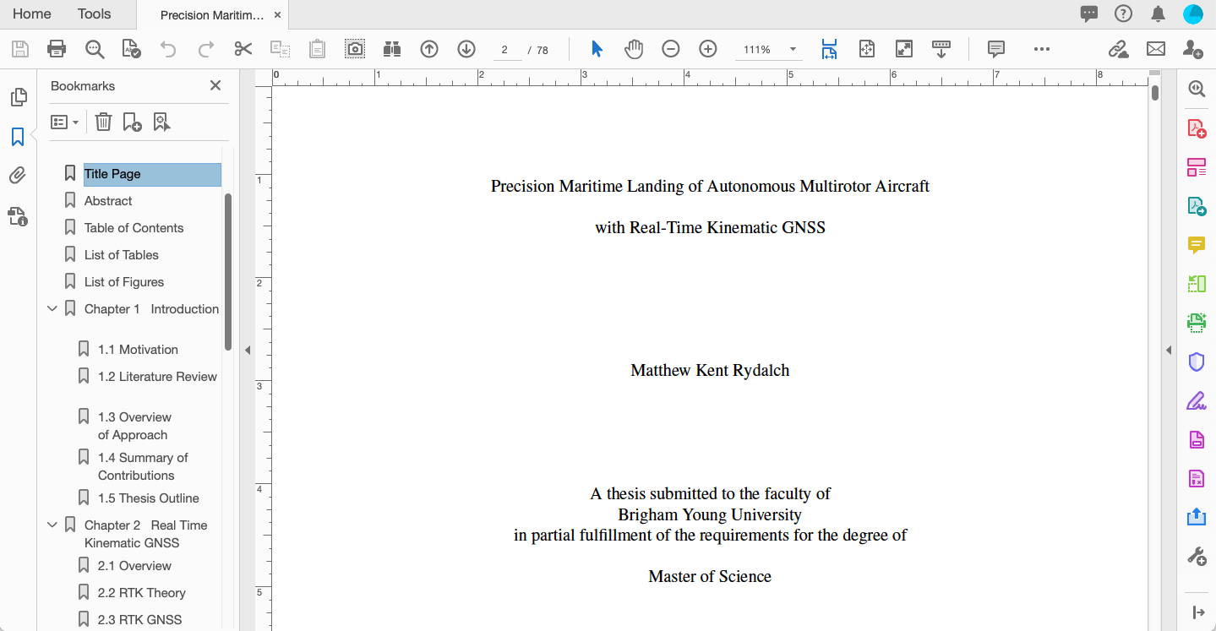
Figure B.1: PDF thesis document showing ETD bookmarks.
If assistance is needed with embedding, bookmarks, or other aspects of submitting the ETD, students may obtain assistance at the Multimedia Lab in the HBLL. Please note that keywords will be requested. They must be in lower case unless they are acronyms or proper nouns. In addition, a copy of the abstract must be inserted.

- Template Format Guidelines
This appendix describes formatting details for this thesis template. While it is not required that you follow exactly these details with exactness, they can be used to help you produce a well-formatted document with the look and feel of this MS Word template.
- Document Margins
BYU title page
- 1-inch top and bottom margins
- 1-inch left and right margins

Custom title page
- 1-inch top and bottom margins
- 1 to 1.75-inch left and right margins

Front matter pages (abstract, acknowledgements, table of contents, list of figures, list of tables, nomenclature)
- 2-inch top margin
- 1-inch bottom margin
- 1.75-inch left and right margins

Chapter title pages, Reference title page, Appendix title pages
- 2-inch top margin
- 1-inch bottom margin
- 1.75-inch left and right margins
- Page Numbering
- Page numbers are centered at the bottom of the page.
- Counting begins with the title page.
- Page numbers do not appear on the page until the table of contents (page v in this template example).
- Use Roman numerals (i, ii, iii ...) for the table of contents and the pages thereafter until Chapter 1 begins.
- Use Arabic numbers (1, 2, 3 ...) beginning with Chapter 1. Be sure numbers appear on all pages once numbering begins.
- Line Spacing
The document should be single-spaced except for space around titles, headings, subheadings, figures, tables, and equations as described below. Please note that the document styles in this template (e.g., Normal, Heading 1, Heading 2, Equation number, etc.) have been defined to conform to these requirements.
- Two-inch margin above chapter titles (144 pts, Heading 1 style).
- 2/3 inch of space after chapter titles (48 pts, Heading 1 style).
- 18 pts before level 2 subheadings (Heading 2 style).
- 6 pts after level 2 subheadings (Heading 2 style).
- 12 pts before level 3 subheadings (Heading 3 style)
- 3 pts after level 3 subheadings. (Heading 3 style)
- 12 pts (1 carriage return with 11-pt font) before figures
- 6 pts between figure and caption, 12 pts between figure and following text (Caption style)
- 12 pts before table caption, 6 pts between caption and table
- 12 pts between table and following text
- 6 pts before and after equations (Equation number style)
- No additional spacing is inserted between consecutive paragraphs, however the first paragraph below a section heading is not indented (Normal – no first-line indent style), while subsequent paragraphs are indented by 0.25 in. (Normal style)
- Avoid leaving a single line of text or a subheading alone on the top (widow) or bottom (orphan) of a page
- Avoid leaving more than 1 inch of extra white space remaining on the bottom of a page unless it’s at the end of a chapter

